**Department of CSE/IT**

**Jaypee Institute of Information Technology**

**Sec 128, Noida**

**MAY 2019**



**ALGORITHMS AND PROBLEM SOLVING LAB**

**(15B17CI471)**

**TOPIC – BLOOD BANK PORTAL**

**Batch: F7**

**SUBMITTED TO:** **SUBMITTED BY:**

Dr. NEERAJ JAIN ANSHIKA BAJPAI 9917103009

VISHAL KUMAR 9917103204

ROHAN KUMAR 9917103227

**DESCRIPTION:**

Our project focuses on how to find and navigate a donor having blood of type as per patient requirement. Patient or user enters their current location; the type of blood required and range (in Minutes) which is most suitable to them. A list of all those locations which are within that range is printed. User can choose the location according to their convenience. Shortest distance and shortest path is printed from the location.

One can also become a donor by submitting details required, the details of donors are stored in a file.

IMPLEMENTATION:

The map of Delhi using Data Structures.

Data is stored using Adjacency list.

List Traversal using Depth Limited Search (DLS).

Shortest Distance and Time using Dijkstra’s Shortest Path Algorithm.

**FUNCTIONS USED:**

* **void traversalOfEdge() O(n2)**

This recursive function is used for traversal of all the vertices that are in the range of patient and storing the shortest time one can take to reach to that location.

* **int shortest_path() O(n2)**

This function is used to get the path(with respect to time) optimal to reach over the destination.

* **float shortest_dist() O(n2)**

This function is used to get the path(with respect to distance) optimal to reach over that same destination.

* **void sortedInsert() O(n)**

This function is used to store the nodes into adjacency list in ascending order of their timeWeight between edges.

* **void getDataFromFile() O(n)**

This functions reads the data of donors from the file.

* **void printOURDONORDETAILS() O(n)**

This function is used to print all the details of donors of that particular blood group and location.

**STRUCTURE USED TO IMPLEMENT MAP:**

* struct locationNode{

int index;

float distWeight;

int timeWeight;

locationNode *next;

};

This structure is used to store all the details required in making the nodes.

**OUTPUT SCREENSHOTS:**

* **FRONT PAGE**

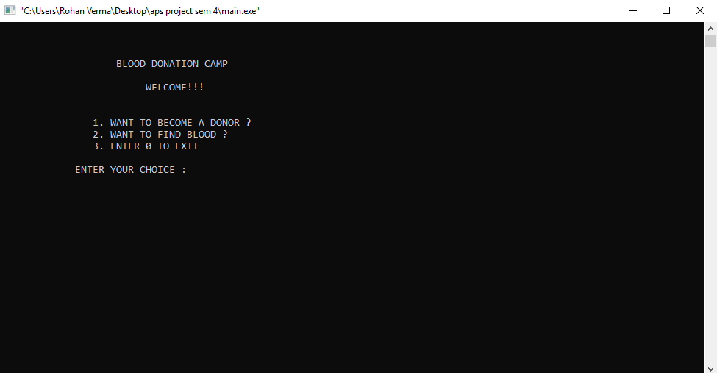

* **INPUT : DETAILS OF DONOR**

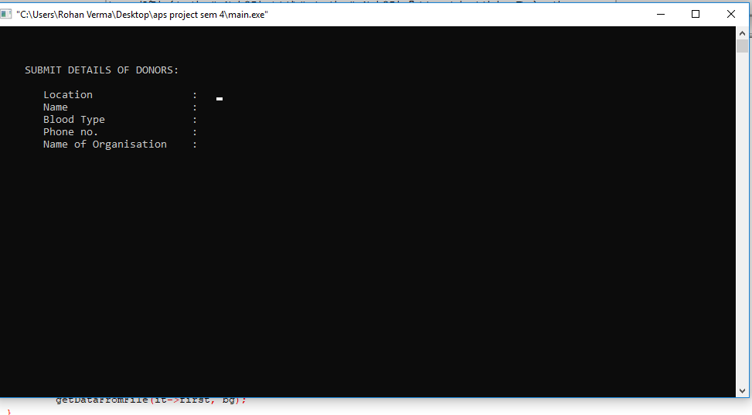

* 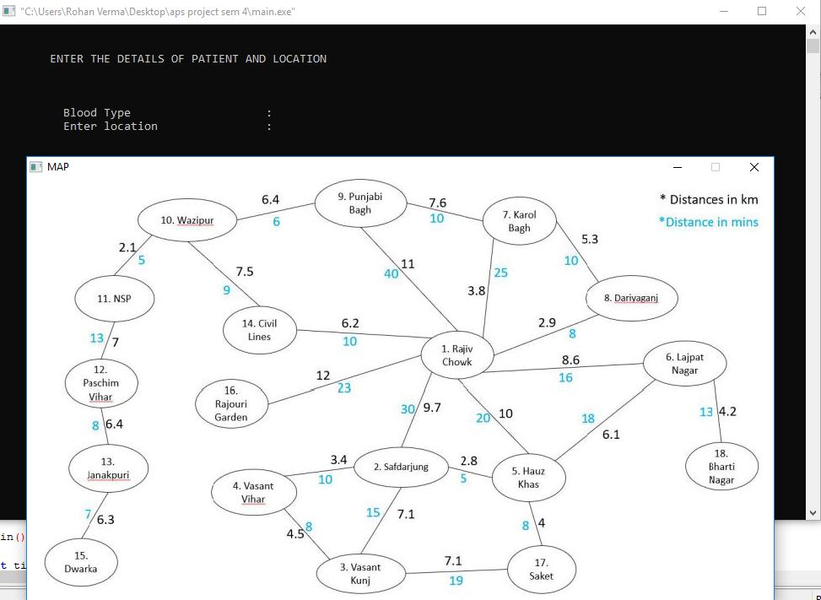**ENTERING REQUIRED BLOOD TYPE AND CURRENT LOCATION(SOURCE)**
* **MAP OF DELHI**



* **LOCATIONS TRAVERSED WITHIN THE RANGE AND SORTED ACCORDING TO TIME**

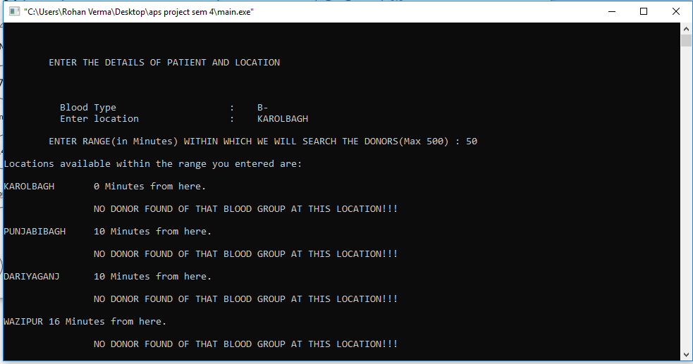

* **PREFFERED LOCATION**

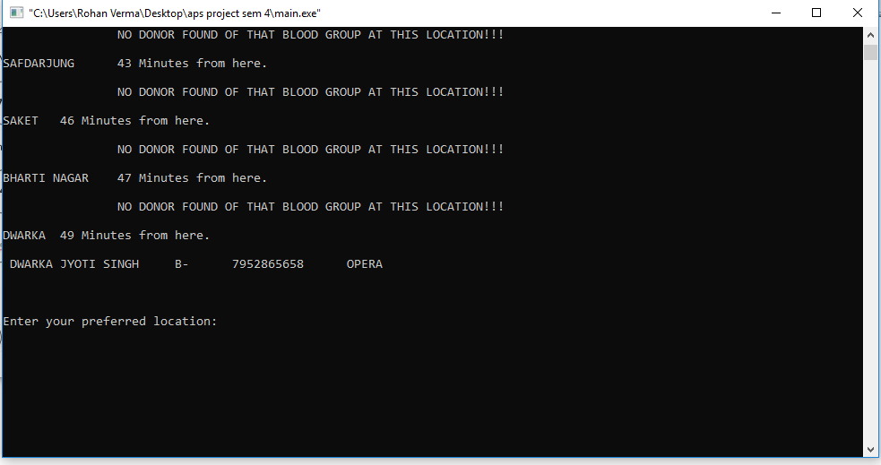

* **OPTIMAL PATH( IN MINUTES) TO REACH TO THAT PREFERRED LOCATION( DESTINATION) AND ALSO OPTIMAL PATH (IN KILOMETERS)**

